# How to log out, and back in to the app on your mobile device

## Android devices

Click the three dots at the top right of your screen (as circled in blue below)

Next click the key at the top right of the Settings page (as circled in orange below)

When asked if you are sure you want to log out, click Ok

You’ll then be asked to choose a profile, choose Current Students/Applicants

Once you have ready the terms and conditions, choose a response (note: unless you agree, you will not be able to use the app)

Enter your student number in to the username line

Enter your password in to the password line

Click Log in

Your view will then refresh with the appropriate tiles for your student journey. This may be different to your fellow students as we tailor the information to give you what you need.

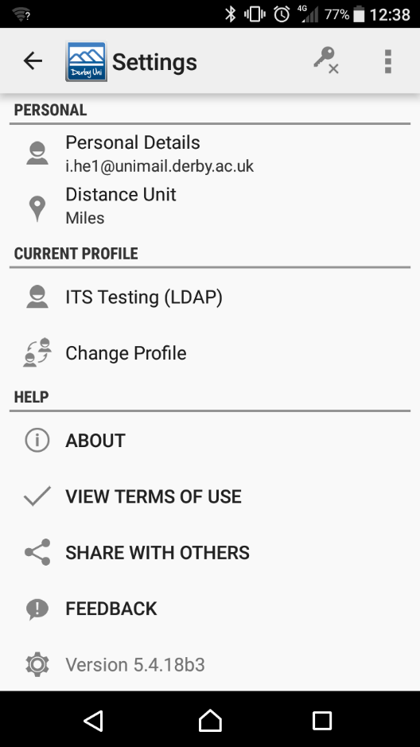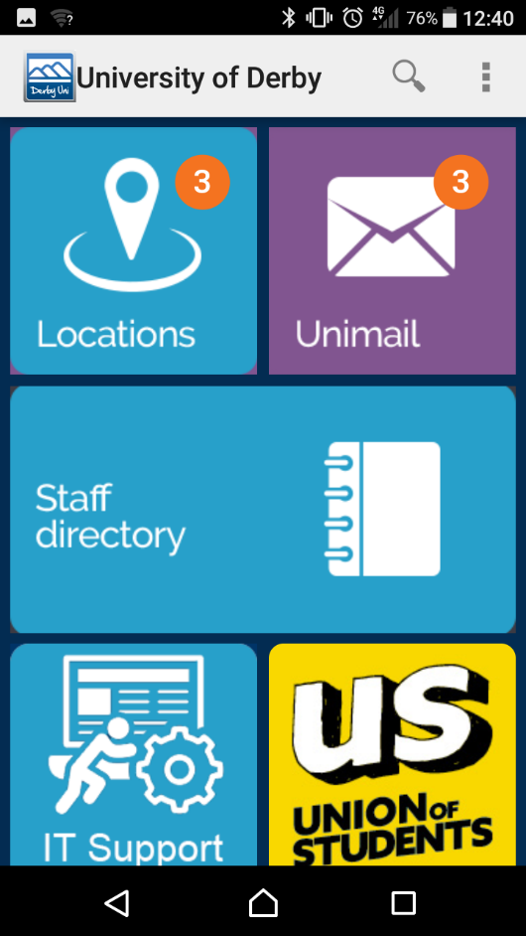

### Apple Devices

In your apple device, click the Settings icon at the bottom of your screen. Click Yes to confirm the logout request.

To log back in, open the app

Choose Current Students/Applicants

Once you have ready the terms and conditions, choose a response (note: unless you agree, you will not be able to use the app)

Enter your student number in to the username line

Enter your password in to the password line

Click Log in

Your view will then refresh with the appropriate tiles for your student journey. This may be different to your fellow students as we tailor the information to give you what you need.

